Obstacle Avoiding Smartcar using Arduino and Ultrasonic Sensors

*submitted by*

*PURAMSETTI VIDYASRI*

*-N181035*

*VENKATESH CHANDRAKALA*

*-N181060*

*SHAIK MASHRUN SABI*

*-N181143*

*RONGALA SATYAVATHI*

*-N181146*

*YAGANTI MYRTLE BITHIAH*

*-N181139*

*submitted to*

*Mr.P.VINOD BABU sir*

*Assistant Professor,Dept. Of ECE*

*RGUKT APIIIT Nuzvid*

*Nuzvid,India*

vinod@rguktn.ac.in

*Abstract-*

Trajectory planning is one of the most important pivotal point in pick and place tasks done by robotic manipulators. In this work, we have presented a robot, which is compact, autonomous and fully functional. This robot or a smartcar is built to sense any obstacle in its path, to avoid it and resume its running involving the pre-computation of an obstacle free path. Ultrasonic sensors were adapted to implement a real-time obstacle avoidance system for wheeled robots, so that the robot can continually detect surroundings, avoid obstacles, and move toward the target area. This model has tremendous applications in vacuum cleaners, avoiding concealed paths, parking systems, assembling automobiles and in chemical industries, in scientific exploration, emergency rescue and in other isolated environments.

We use an Arduino UNO with a Motor Shield along with Stepper Motors to make the car, and for sensing we incorporate an Ultrasonic Sensor which accurately and efficiently detects any obstacles in the smart car’s path. The Arduino is coded such that the smartcar moves backward when an obstacle arises in front of it with a maximum limit of 50cms in ideal testing conditions.

Throughout the construction of this model, we educated ourselves to the Arduino coding language, the Motor Shield functionality, and comprehensively, with the working of an ultrasonic sensor and its features.

**Keywords** : Arduino UNO , Ultrasonic sensor , Motor driver shield (L293D) , Servo motor , Jumper wires , Chasis board , Wheels , Battery(li-ion)-9V , Gear motors-x4 .

# **Introduction**

Robotics is the branch of technology that deals with the design, construction, operation, and application of robots. A machine capable of carrying out a complex series of actions automatically, esp. one programmable by a computers is defined as a robot. And, Obstacle avoidance refers to the ability of a robot to detect obstacles in its way if there are any and thus make its own obstacle free path.

The thesis deals with two steps; first making an obstacle avoiding robot and second, introductory guideline to the first year engineering students. The thesis will help them to learn about physics when dealing with terms like Infrared (IR), IR sensors, electromagnetic spectrum, and also with embedded computing while making the robot. The Board of Education (BOE-Bot) is our working basement of the project. BOE-Bot is relatively simple programmable robot series which does not require any deep knowledge of robotics, programming, or electronics.

The project is to develop a robot that will move according to the code assigned but find a free space, navigating from any obstacle on its way. This kind of obstacle is very useful in industries where automated supervision is needed, for example, in places where it might be risky for humans to be. This robot can also be made by putting other sensors like light sensors or line sensors depending on the need. However, putting camera in the robot will make it a smart robot that this may help humans if needed. For example, it might not always be possible to go to every places but we can send this robot which will be there making its own path and send different information.

The project provides a guideline to the students who are new in the world of Arduino and help them to understand about embedded system, IR sensors, microcontroller and how to make a robot using Arduino. The thesis will make students learn more about basic knowledge and skills regarding servo, program and mathematics to calculate program values. New students will learn how to program the BOE-Bot to perform basic maneuvers and gradual acceleration and deceleration of the robot to get robot out of maneuvers and also students will learn to write subroutines to perform basic maneuvers.

The aim of the thesis is to evaluate what students can learn about the fields of engineering, mechatronics, and software development as they design, construct, and program an autonomous robot. The thesis not only gives detailed information about Arduino and the use of App Inventor for android application design but also about the IR, IR sensors, PBASIC programming platform to the new students or beginners. The guidelines provided are very simple to use and understand thus, making it very easy for the new students to build a foundation in their Robotics learning. This project is very much helpful to the first year students who have a keen desire and interest in the robotics and specially Arduino robotics. From this students will learn about servo motors and how to program them.

**II. COMPONENTS USED**

**1. ARDUINO UNO**

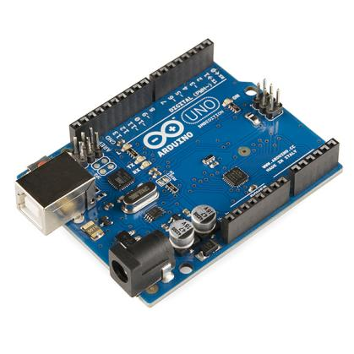 Arduino UNO is a microcontroller board based on the Atmega 328P it has 14 digital input/output pins , 6 analog inputs , a 16MHz quartz cristal,a USB connection, a power jack, an ICSP header and a reset button. It contains everything needed to support the microcontroller; simply connect it to a computer with a USB cable or power it with a AC-to-DC adapter or battery to get started. You can tinker with your UNO without worrying too much about doing something wrong, worst case scenario you can replace the chip for a few dollars and start over again.

### Features of Arduino Uno Board

* The operating voltage is 5V
* The recommended input voltage will range from 7v to 12V
* The input voltage ranges from 6v to 20V
* Digital input/output pins are 14
* Analog i/p pins are 6
* DC Current for each input/output pin is 40 mA
* DC Current for 3.3V Pin is 50 mA
* Flash Memory is 32 KB
* SRAM is 2 KB
* EEPROM is 1 KB
* CLK Speed is 16 MHz

**3. ULTRASONIC SENSOR:**

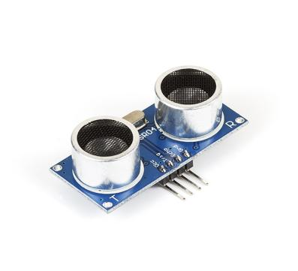 The Ultrasonic Sensor sends out a high- frequency sound pulse and then times how long it takes for the echo of the sound to reflect back. The sensor has two openings on its front. o Tiny speaker to transmit opening ultrasonic waves o Microphone to receive the ultrasonic waves

The ultrasonic sensor calculates distances by

The speed of sound is approximately 341 meters per second in air. The ultrasonic sensor uses this information along with the time difference between sending and receiving the sound pulse to determine the distance to an object. It uses the following mathematical equation:

Distance = time x speed of sound

2

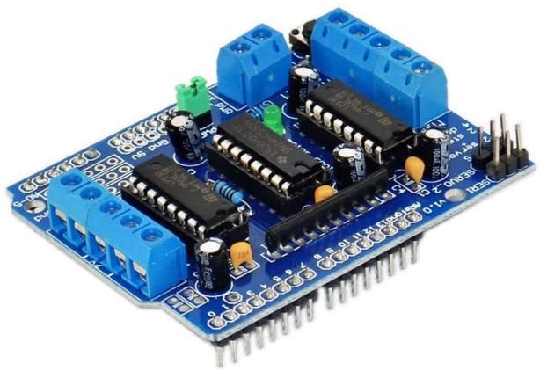**Motor Shield:**

The Arduino Motor Shield allows the user to easily control motor direction and speed using an Arduino. Arduino pins are straightforward and hence it makes it

very simple to incorporate a motor into a project.

It also allows you to be able to power a motor with a separate power supply of up to 12V.

- The motor shield has 2 channels, which allows for the control of two DC motors, or 1 stepper motor.

- An external power supply, the motor shield can safely supply up to 12V and 2A per motor channel

- There are pins on the Arduino that are always in use by the shield.

-By addressing these pins one can select a motor channel to initiate, specify the motor direction (polarity), set motor speed (PWM), stop and start the motor, and monitor the current absorption of each channel .

3. SERVOMOTOR:

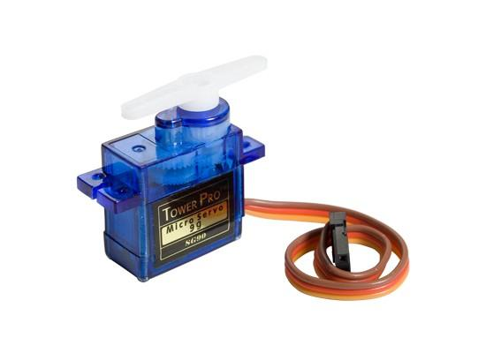A servomotor is a simple electric motor, controlled with the help of servomechanism. If the motor as a controlled device, associated with servomechanism is ,DC motor then it is commonly known as a DC Servo Motor. If AC operates the controlled motor, it is known as a AC Servo Motor.

There are some special types of applications of an electric motor where the rotation of the motor is required for just a certain angle. For these applications, we require some special types of motor with some special arrangement which makes the motor rotate a certain angle for a given electrical input (signal). For this purpose, servo motor comes into the picture.

The servo motor is usually a simple DC motor controlled for specific angular rotation with the help of additional servomechanism (a typical closed loop feedback system). Nowadays, servo systems are used widely in industrial applications.

4. JUMPER WIRES : 5. GEAR MOTORS :

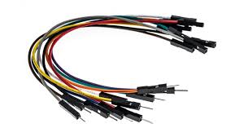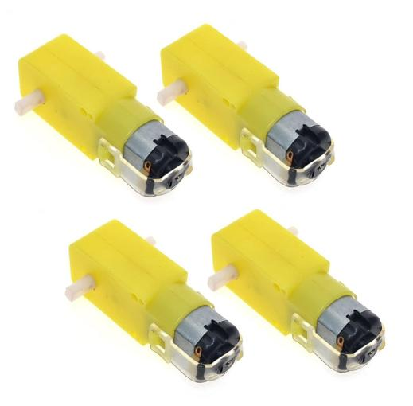

6. CHASIS BOARD : 7. LI-ION BATTERY :

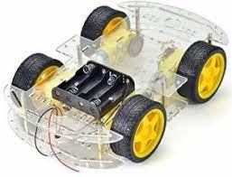

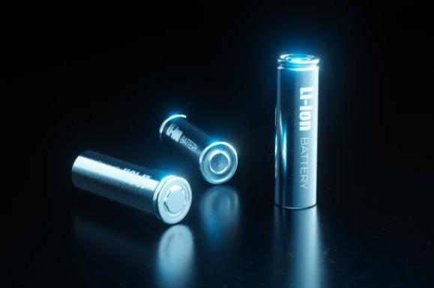

# **III.BLOCK DIAGRAM**

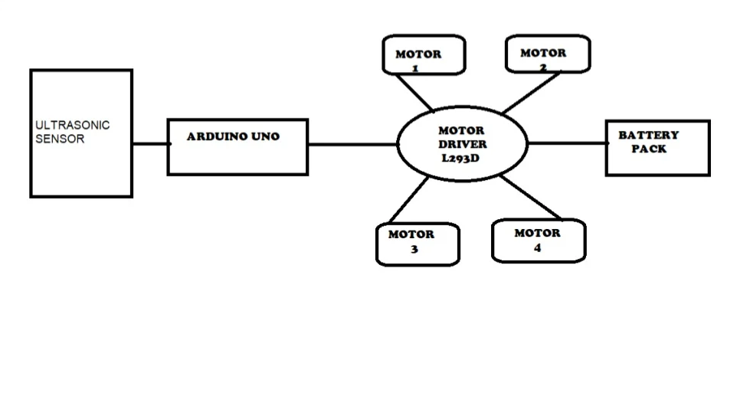 IV. PROCEDURE

Getting the hardware ready

### *S*tep 1: Attach the Motor and Wheel to the Chassis

Connect the wire to all motors And then fix all those motors on the chassis with glue

### Step 2: Attach Arduino in Chassis

1. Now put the Arduino in the chassis

**2. Fix the arduino on the nut and bolt through the chassis. You can also fix it with Dobble sided tape.**

Step 3: Connet Motor Wire in Arduino

1.Connect all motor wires to the motor driver.

**2.First attach all the motor wires to the motor driver's pins.**

### Step 4: Mount the ULTRASONIC Sensor With Servo

**1. First fix the servo motor with glue on the chassis.**

**2.Then I put the ultrasonic sensor on the servo so that the ultrasonic sensor can rotate.**

### Step 5: Connect the Servo and Sensor Wire in Motor Shield

**1.** Ultrasonic sensor Arduino UNO

* TRIG PIN -A0

* ECHO- A1

* GND - GND

* VCC - 5V

2. SERVO PIN Motor Shield

* All Servo pin

### **Step 6: Power Source**

1. Use 18650 battery to power the Arduino. You can do another one as well.

**2. Power the motor driver with the battery.**

**3. Place the battery in the holder.**

### Step 9: Complete

**Getting the software ready**

**- Download and install the Arduino IDE**

**- Before doing anything in the Arduino programmer, set the board-type and serial port.**

**- To set the board, go to the following:**

**- Tools - Boards o Select Arduino Uno.**

**- To set the serial port, go to the following:**

**▪ Tools - Serial Port**

**WORKING :**

**- The robot is switched on by giving it 5V DC power from an external battery. The motors starts rotating and thus the robot starts moving forward.**

**- During this time, the ultrasonic sensors continuously keep calculating the distance between the robot and the reflective surface.**

**-This information gets processed by the ARDUINO.**

**- If the distance between the robot and the obstacle is less than the specified value, the robot changes its path(moves towards the back).Here, we have kept the minimum distance to be of 15cm.**

- This process continues forever and the robot keeps moving without danger.

v. Schematic

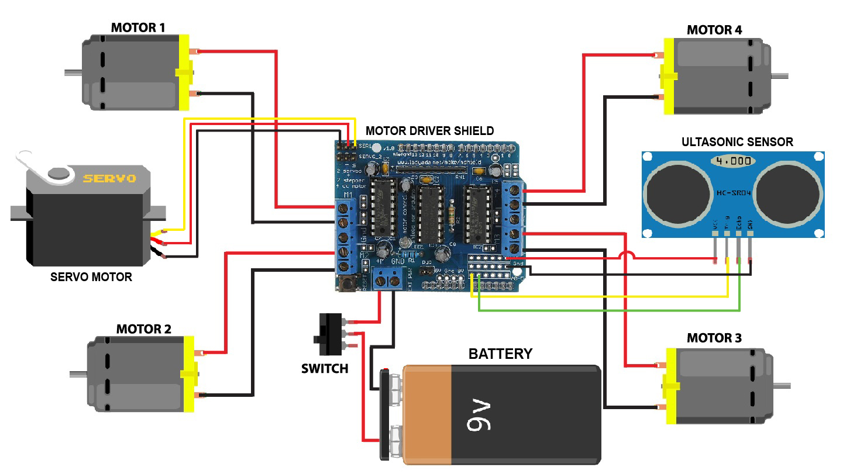

IV. APPLICATIONS

1. Used in mobile robot navigation systems

2. Used for household work like automatic vacuum cleaning

3. Used in dangerous environments, where human penetration could be fatal.

4. Automatic change over’s of traffic signals

5. Intruder alarm system

6. Counting instruments access switches parking meters

7. Back sonar of automobiles

**9.This robot can be used for avoiding concealed paths, such as an**

**industrial robot in a factory is expected to avoid workers so that it won hurt .**

**10. It will be very useful in parking system.**

**11. It can also be used in assembling automobiles and in chemical industries.**

**12.If there is an obstacle in the root of the robot, it can detect and avoid it.**

**Thus it can move without having damaged by any obstacle which makes**

**it more reliable**

**13. They have great importance in scientific exploration and emergency**

**rescue, there may be places that are dangerous for humans or even**

**impossible for humans to reach directly, then we should use robots to**

**help us gather information to about their surrounding challenging**

**environments.**

**8.The modification of this logic code is used in vacuum cleaners.**

V. FLOW CHART

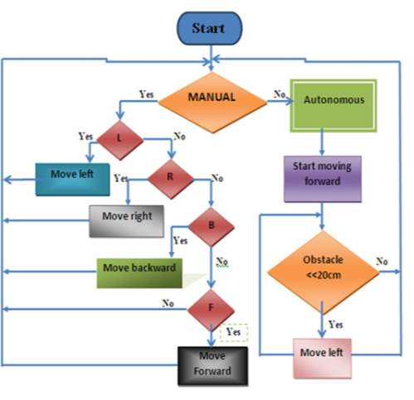

VI. RESULT ANALYSIS

The result is obtained for obstacle avoidance robot using Arduino, if the robot moves forward if any obstacle detect it check for other directions and moves where there is no obstacles it moves in forward direction, to sense the obstacle ultrasonic sensor is used. We used servo motor to rotate the ultrasonic sensor

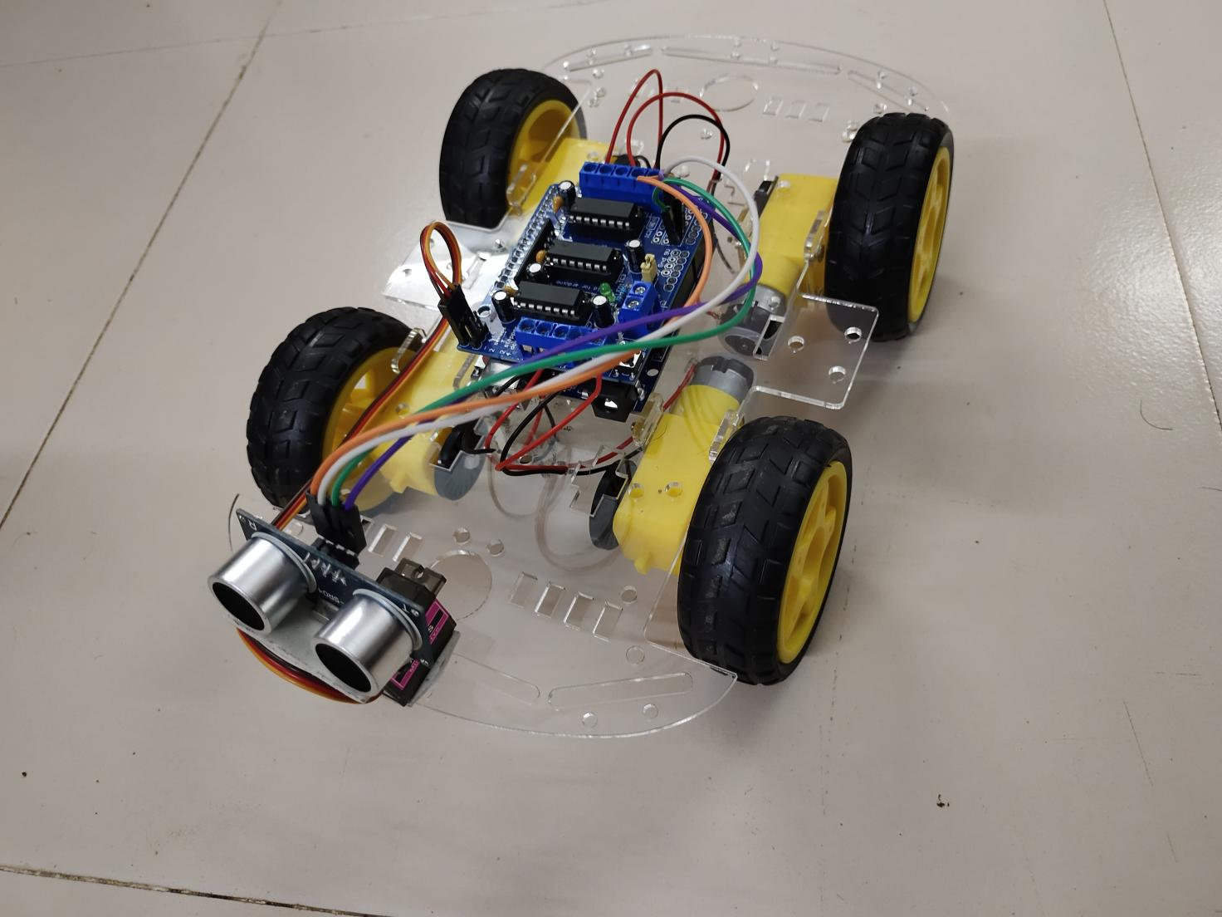

VII. CONCLUSION AND FUTURE SCOPE

This project developed an obstacle avoiding robot to detect and avoid obstacles in its path. The robot is built on the Arduino platform for data processing and its software counterpart helped to communicate with the robot to send parameters for guiding movement. For obstacle detection,three ultrasonic distance sensors were used that provided a wider field of detection.

The robot is fully autonomous and after the initial loading of the code, it requires no user intervention during its operation. When placed in unknown environment with obstacles, it moved while avoiding all obstacles with considerable accuracy. In order to optimize the movement of the robot, we have many considerations for improvement. However, most of these ideas will cost more money and time as well. In future cameras can be used to detect the obstacle however, it is better to get CCD or industrial use ones to get clear and fast pictures. Even the ones we mentioned in the camera holder part will be better because of the special software

VIII. REFERENCES

1. <https://srituhobby.com/obstacle-avoidance-robot-car/>

2. Paul Kinsky,Quan Zhou “Obstacle Avoidance Robot” Worcester polytechnic institute.

3. Vaghela Ankit1, Patel Jigar2, Vaghela Savan3 “Obstacle Avoidance Robotic Vehicle Using Ultrasonic Sensor, Android And Bluetooth For Obstacle Detection” International Research Journal of Engineering and Technology (IRJET), vol. A247, pp. 29-32, 2005.